User Support in European Universities
Hanousek, P., Šustr Z., CIV – ZČU v Plzni
XXX. EurOpen Conference, May 19 – 22, 2007
Leverage Leverage Leverage Leverage Leverage Leverage Leverage Leverage Leverage Leverage Leverage Leverage Leverage Leverage Leverage Leverage Leverage Leverage Leverage Leverage Leverage Leverage Leverage Leverage Leverage Leverage
Introduction
Institutional user support is a must for any large organization. It creates an interface allowing the users to simply access information regarding the computer environment. It also simplifies the process of requesting and providing assistance.
University environment is rather specific – a large number of users, majority of whom are not full-time employees (mostly students and external lecturers), who tend to exercise their “academic freedom” and stretch it as far as possible.
Participating Organizations
 | University of West Bohemia in Pilsen (UWB)
 | Technische universität Chemnitz
 | Universität Regensburg
 | Brunel university
 | University of Bath

Initial Conditions
Being inquisitive by nature, university staff often try to develop their own solutions regardless of what the rest of the world is doing. That is why the situation at any given university is unique and support teams often struggle to solve problems that have been successfully addressed elsewhere.
Equally often, a solution that could really suit other universities arises, ready to be spotted by any team looking for it. That was the fundamental idea of the UWB-initiated project aiming at visiting selected foreign universities looking for ideas and solutions.
Most universities have established “Computer Centres” – departments responsible for servicing university-wide IT systems. Some are only in the middle of the process of transferring responsibilities to such centres. The project tries to look into all aspects of Information Centre / University interaction and aims at determining the correct distribution of authorization and responsibilities.
Topic Checklist
To achieve comparable results, a list of topics (questions) was created addressing the most important areas
- What types of support does the Computer Centre provide (remote, on-the-spot, walk-in), what are the priorities, how many resources are provided for each type of support, do HelpDesk Employees participate in providing various types of support, ...
- How does the HelpDesk educate its staff.
- Who decides what to support.
- Is there any other department providing end-user support at the university?
- Tools used by the support team, experience. Systems for recording/keeping track of user requests.
- Experience with remote support, tools used (such as RealVNC), related issues.
- The way of dealing with known troublemakers. (Does the HelpDesk take a special approach, is there a Penalty Code?)
- Multilanguage support.
- Web pages, editorial systems, how to give publicity to web pages, ...
Computer Centre Roles
While almost all universities have their own computer centres, these centres' roles are not unified. In some cases, Computer Centres provide only centralized services that cannot be taken care of by individual divisions, faculties, or even departments. In other cases, Computer Centres are responsible for all computer-related issues.
Surprisingly, the problems these centres need to solve are not unalike. They may only vary in magnitude.
Computer Centres participating in this Case Study provide limited services to faculties as well as to the administrative branches of their respective universities. Their responsibilities are similar.
Local Support Staff
All universities participating in this project rely to some extent on cooperation with “local administrators” or “workgroup managers” who are not employed directly by the Computer Centres. These specialists belong to their respective departments/faculties and carry out local administrative tasks.
All organizational units should create a formal position (possibly part-time) for such a local administrator. Its is considered good practice to hold regular meetings with all local administrators to keep them informed of new developments and to gather feedback.
In case of some universities (UWB, for example), the role of a local administrator (contact person) is recognized only informally, which affects the information flow. Universities which have succeeded in forcing their departments to create formal workgroup manager positions seem to experience less trouble spreading know-how and skills throughout the organization. Obviously, this requires top management support.
HelpDesk Software
To work efficiently, a HelpDesk needs a centralized “dashboard” to access multiple information resources. An absolute minimum is a request/issue tracking system (RT, Remedy, OTRS, HP-OV ServiceDesk, ...) and an asset management system, preferably complemented with other systems (call management, automated knowledge base look-up, etc.)
Almost any imaginable mix (ability to interoperate) of such systems yields perceivable benefits – work efficiency, convenience, and – ultimately – user satisfaction.
The HelpDesk also needs to interact with users (publish information, be easily available, ...), which is why it needs a robust Content Management System (MediaWiki at UWB).
Currently most universities are struggling to integrate these single-purpose solutions and create a complex management system which suits their specific needs.
HelpDesk Staff Retention
There is no uniform approach towards tackling staff fluctuation. While some universities (Chemnitz) keep their staff for long periods of time, others (Regensburg) rely on temporary workforce (students who keep working for the HelpDesk for no more than two years), both reporting satisfactory results.
Apparently, staff fluctuation is not a problem as long as effective training process stays in place with training materials usually created and kept by HelpDesk staff themselves.
Shared Knowledge Base
Experience gained in all participating universities shows that a knowledge and reference base should be kept by the HelpDesk staff. Not only do HelpDesk employees know the most pressing topics but they can also use their expertise to point out the most important facts and present them in such a way that is best understood by both their colleagues and their users.
While a portion of the HelpDesk's documentation should still be prepared by the technical staff (administrators, maintainers, developers), global documentation repository needs to be managed by HelpDesk personnel.
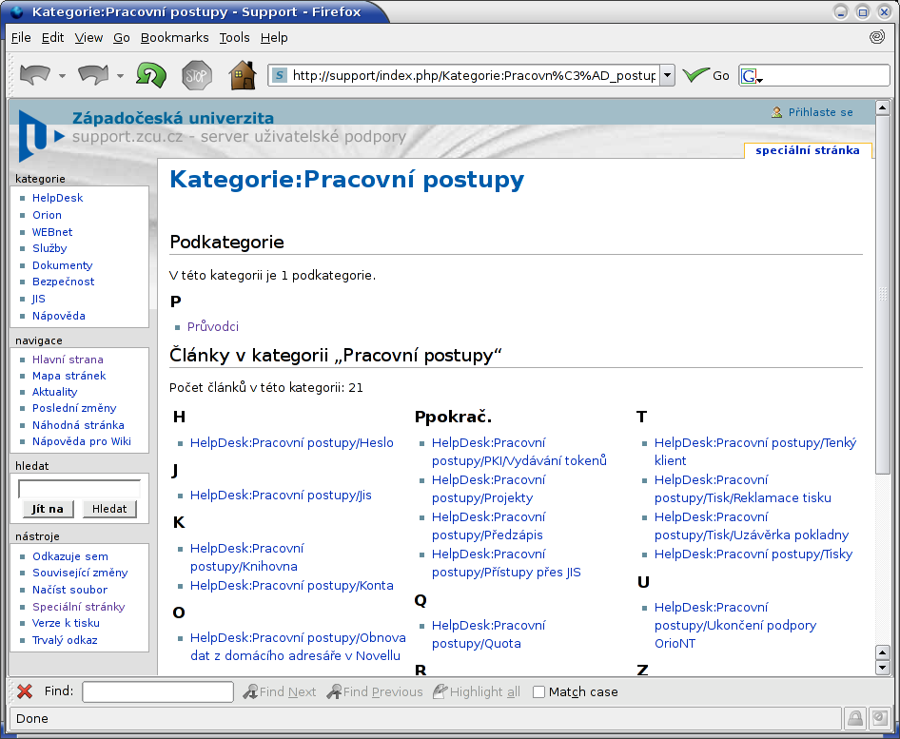Figure 1: HelpDesk processes – part of the Knowledge Base
Parts of the knowledge base also need to be accessible to the public (ie. users seeking information on their own) although users are seldom prepared to solve their problems themselves. All too often, publishing user information on the Web is only done to create a kind of an alibi (“It's not our fault, it's on the web.”).
Strict Process Definition
It seems beneficial to introduce rather formal definitions of rules and processes (the idea being that it is better to provide slightly lower-quality service consistently than high-quality and time-consuming care selectively).
That is why the HelpDesk now operates on a set of guidelines explicitly defining its responsibilities and discouraging HelpDesk operators from providing service beyond these strictly set limits. This has solved time lag problems experienced by users who often had to wait for the appropriate support person to finish time-consuming tasks they technically were not supposed to take care of at all.
Note: The Brunel University is an example worth following in this respect. It has put into effect the most comprehensive set of rules the authors of this poster have ever seen at Czech, European or even American universities.
HelpDesk Environment
Among other activities, the University of West Bohemia's Computer Centre has also invested resources in reconstructing the area adjacent to the HelpDesk site itself.
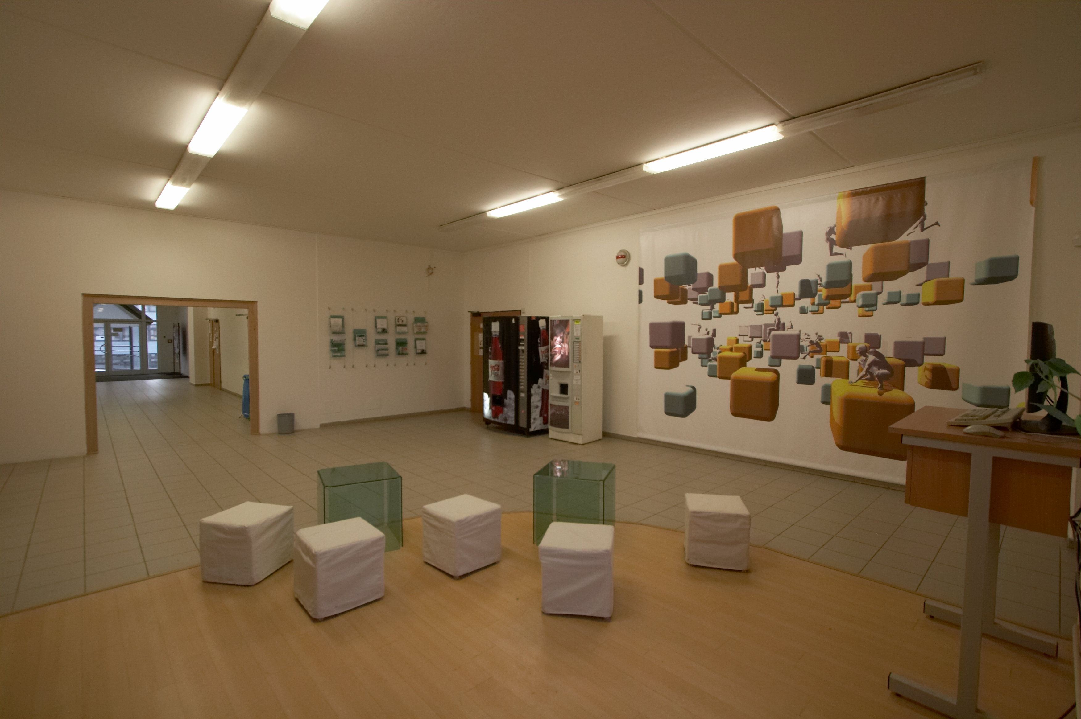
Figure 2: Newly furnished HelpDesk area at UWB
This photo shows a portion of the students' common room hosting, among others, self-service printers (out of sight) and a computerized information stand.
Automated CallCentre Support
Operating a modern HelpDesk is not feasible without implementing at least a basic CallCentre software for managing incoming calls. Such a software is not only capable of observing the availability of operators and holding calls until a staff member becomes available; important results and service improvements are also expected from the software's automation capabilities as well as call recording/monitoring features.
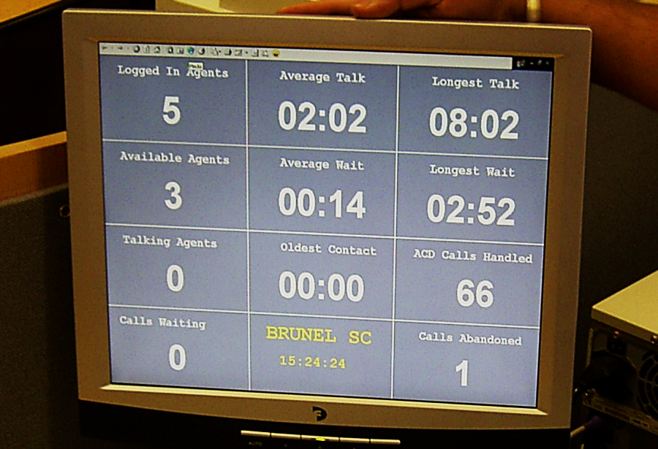Figure 3: CallCentre monitoring system at Brunel University
Note: Basic functions offered by low-end enterprise exchanges (grouping, etc.) do not usually suffice – the system needs at least to adapt to the current number of operators available/logged in.
Defining Policies
Introducing a well-established policy is key to every computer centre operation. Since the central policy would usually be the only “legal” document recognized by the whole university, it needs to address all issues that may arise in the future. Also, policies need to be in place before process definition (see above) takes place.
As of yet, there is no common opinion on incorporating Penalty Codes into policies. Many universities tend to turn their back, repair the damage and hope that the offenders will learn better in time. Since students do not usually fall under the authority of a computer centre, any penalties need to be awarded by their respective faculties who are often not capable of recognizing the severity of the offence. The only solution is having the Computer Environment Policies codified high enough in the hierarchy of the university's legal structure so that all faculties are simply bound by the rules and have to observe them.
For further information, visit:
http://support.zcu.cz
http://support.zcu.cz/index.php/Public:Phanousk/FRCesnet2006
http://www.tu-chemnitz.de  http://www.uni-regensburg.de | http://www.brunel.ac.uk/  http://www.bath.ac.uk/

